Fast Symmetric Diffeomorphic Image Registration with Convolutional Neural Networks Background:

Initial problems:

Although these methods achieve fast registration and comparable registration accuracy in terms of average Dice score on the anatomical segmentation map, **the substantial diffeomorphic properties of the transformation are not guaranteed.** In other words, **some desirable properties, including topology-preservation and the invertibility of the transformation, for medical imaging studies have been ignored** by these approaches.

Work:

In this paper, we propose a novel fast symmetric diffeomorphic image registration method that parametrizes the symmetric deformations within the space of diffeomorphic maps using CNN. Specifically, **instead of pre-assuming the fixed/moving identity of the input images and outputting a single mapping of all voxels of the moving volume to fixed/target volume, our method learns the symmetric registration function from a collection of n-D dataset and output a pair of diffeomorphic maps (with the equivalent length) that map the input images to the middle ground between the images from both geodesic path.**

主要的亮点：

1. a fast symmetric diffeomorphic image registration method

2. a novel orientation-consistent regularization to penalize the local regions with negative Jacobian determinant

Algorithm:

Deformable registration:形变配准的原理



Fix_img和Mov_img的差值+平滑正则

Diffeomorphic Registration：微分配准

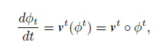

Vt: t时刻的velocity field o：合成算子

再提及现有的无监督配准存在的问题：

It is worth noting that most of the existing CNN-based methods parameterize the registration problem with displacement vector fields and **ignore the desirable diffeomorphic properties, including topology preservation and the invertibility of the deformation field.**

1. 虽然采用了正则化函数加强的平滑性，但不能保证位移矢量在局部区域内的平滑性和方向一致性
2. 没有/不考虑到逆变换

所以这个问题出在哪呢？文中意思是在我们无监督配准中输入了两类mov_img以及fix_img，并往往只考虑了单一映射，逆映射被忽略。而在这篇文章的方法中实际上取消了输入图像什么作为mov_img什么作为fix_img.

Method :





we propose to learn the two separated time 0:5 deformation fields that warp bothX and Y to their mean shape M in the geodesic path.

可得：



同理： …

所以最后：



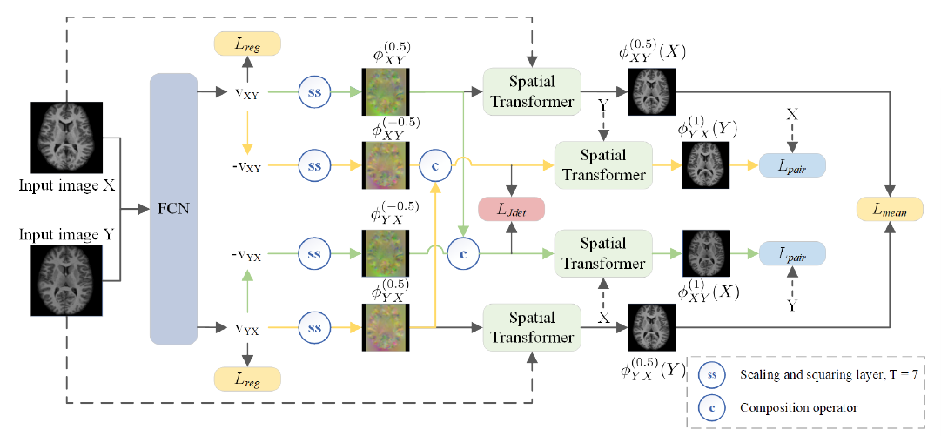

其中绿色部分表面X->Y,黄色部分表面Y->X,最终获得Lmean

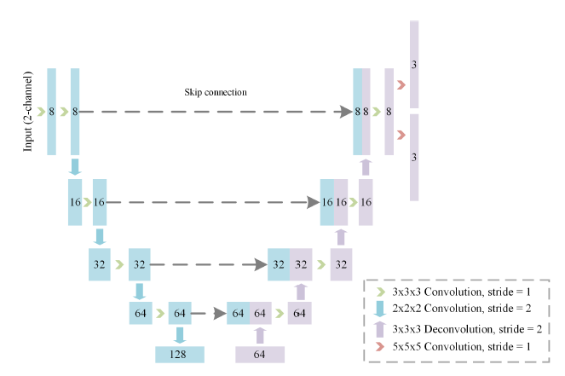

FCN网络感觉就像一个5层U-NET，不难理解用来学习Vxy与Vyx

可逆向运算的性质：

Since the deformation fields are diffeomorphic and the mapping is one-to-one, we exploit the fact that the inverse transformations can be computed by integrating the same velocity field backward.

损失函数：

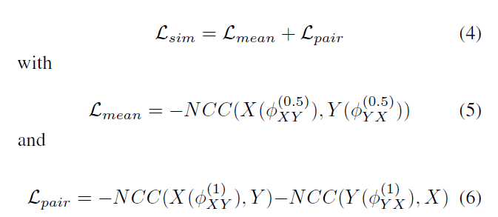

Lmean 计算wrap_imgX->Y（0.5）与wrap_ingY->X（0.5）的差距

Lpair计算 wrap_imgX->Y（1）与Y+ wrap_ingY->X（1）与X

minimizing the Lsim tends to maximize the similarity of the warped images in a bidirectional fashion.

Local Orientation Consistency：

we propose a novel selective Jacobian determinant regularization that imposes a local orientation consistency constraint on the estimated deformation field.

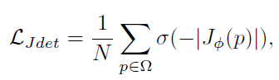

但是文中也提及了使用Jacobian determinant正则化并不是取代全局正则化

平滑性：



 

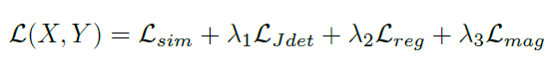

我的总结：

该文章改变了大家一直在用的无监督配准方法（以voxelmorph为例）的模式。1.采用对称微分的思想，使两幅图像在形变映射空间内对齐到其平均形状。2. 提出了一个新的局部方向一致性损失，利用雅可比行列式进一步保证得到的解的理想的微分纯性质，大概就是方向一致，可逆运算等等，解决了传统正则化的劣势。